

***Mini project report on***

Student Database Management System

*Submitted in partial fulfilment of the requirements for the award of degree of*

**Bachelor of Technology**

**in**

**Computer Science & Engineering**

**UE21CS351 – DBMS Project**

***Submitted by:***

|  |  |
| --- | --- |
| **Heemaj Yadav**  **Isha V Rao** | **PES2UG21CS198**  **PES2UG21CS205** |

Under the guidance of

**Dr. Mannar Mannan**

Assistant Professor

|  |
| --- |
| Designation  PES University |

**AUG - DEC 2023**

**DEPARTMENT OF COMPUTER SCIENCE AND ENGINEERING**

FACULTY OF ENGINEERING

**PES UNIVERSITY**

(Established under Karnataka Act No. 16 of 2013)

Electronic City, Hosur Road, Bengaluru – 560 100, Karnataka, India



**PES UNIVERSITY**

(Established under Karnataka Act No. 16 of 2013)

Electronic City, Hosur Road, Bengaluru – 560 100, Karnataka, India

**CERTIFICATE**

*This is to certify that the mini project entitled*

**Student Database Management System**

*is a bonafide work carried out by*

|  |  |
| --- | --- |
| **Heemaj Yadav**  **Isha V Rao** | **PES2UG21CS198**  **PES2UG21CS205** |

In partial fulfilment for the completion of fifth semester DBMS Project (UE20CSS301) in the Program of Study -Bachelor of Technology in Computer Science and Engineering under rules and regulations of PES University, Bengaluru during the period AUG. 2022 – DEC. 2022. It is certified that all corrections / suggestions indicated for internal assessment have been incorporated in the report. The project has been approved as it satisfies the 5th semester academic requirements in respect of project work.

|  |  |
| --- | --- |
| Signature  Dr. Mannar Mannan  Assistant Professor |  |

**DECLARATION**

We hereby declare that the DBMS Project entitled **Student Database Management System** has been carried out by us under the guidance of **Dr. Mannar Mannan, Assistant Professor** and submitted in partial fulfilment of the course requirements for the award of degree of **Bachelor of Technology** in **Computer Science and Engineering** of **PES University, Bengaluru** during the academic semester AUG – DEC 2023.

|  |  |  |
| --- | --- | --- |
| **Heemaj Yadav**  **Isha V Rao** | **PES2UG21CS198**  **PES2UG21CS205** |  |

**ACKNOWLEDGEMENT**

I would like to express my gratitude to Prof. Mannar Mannan, Department of Computer Science and Engineering, PES University, for her continuous guidance, assistance, and encouragement throughout the development of this UE21CS351 - DBMS Project.

I take this opportunity to thank Dr. Sandesh B J, C, Professor,ChairPerson, Department of Computer Science and Engineering, PES University, for all the knowledge and support I have received from the department.

I am deeply grateful to Dr. M. R. Doreswamy, Chancellor, PES University, Prof. Jawahar Doreswamy, Pro Chancellor – PES University, Dr. Suryaprasad J, Vice-Chancellor, PES University for providing to me various opportunities and enlightenment every step of the way. Finally, this DBMS Project could not have been completed without the continual support and encouragement I have received from my family and friends.

**ABSTRACT**

The Student Management System (SMS) is a comprehensive database-driven solution designed to streamline and enhance the management of student information within educational institutions. This system serves as a centralized repository for storing, retrieving, and managing diverse student-related data, providing administrators, faculty, and staff with a powerful tool to efficiently handle various aspects of student administration.

Key features of the Student Management System include student enrollment management, department management, performance reviews, attendance tracking, and document management. The system ensures data accuracy and integrity by implementing robust validation mechanisms, while its user-friendly interface facilitates easy navigation for all stakeholders.

# 

# TABLE OF CONTENTS

|  |  |  |
| --- | --- | --- |
| **Chapter No.** | **Title** | **Page No.** |
|  | **INTRODUCTION** | **11** |
|  | **PROBLEM DEFINITION** | **12** |
|  | **ER MODEL** | **13** |
|  | **ER TO RELATIONAL MAPPING** | **14** |
|  | **DDL STATEMENTS** | **15** |
|  | **DML STATEMENTS** | **20** |
|  | **QUERIES (SIMPLE QUERY AND UPDATE AND DELETE OPERATION, CORRELATED QUERY AND NESTED QUERY)** | **23** |
| **8.** | **TRIGGERS** |  |
| **9.** | **FRONT END DEVELOPMENT** | **40** |
| **REFERENCES/BIBLIOGRAPHY** | | **41** |
| **APPENDIX A DEFINITIONS, ACRONYMS AND ABBREVIATIONS** | | **42** |
|  | |  |

**INTRODUCTION**

Welcome to the Student Database Management System powered by Streamlit and Python. This comprehensive system is designed to efficiently manage various aspects of student information, attendance tracking, performance reviews, departmental details, leave records, class teacher assignments, and document management.

**System Features:**

1. **Student Information:**

- The core of our system revolves around the student table, where detailed information about each student is stored. This includes personal details, contact information, and other relevant data.

2. **Attendance Tracking:**

- Keep a close eye on student attendance with the dedicated attendance table. This feature allows for easy tracking of student presence and absence, providing insights into their regularity.

3. **Performance Review:**

- Evaluate student performance using the performance review table. This module helps in recording and analyzing academic achievements, grades, and overall progress, facilitating better decision-making for educators and administrators.

4. **Department Details:**

- Manage department-related information with the department table. This includes details about different academic departments, faculty members, and other relevant data to streamline administrative processes.

5. **Leave Records:**

- Keep track of student leave records efficiently. The system maintains a comprehensive leave record table that captures details of student leaves, reasons, and duration, helping administrators and faculty members manage student absences effectively.

6. **Class Teacher:**

- Easily assign and track class teachers with the classteacher table. This feature simplifies the process of assigning responsible educators to specific classes, enhancing communication and coordination.

7. **Document Management:**

- Store and organize essential documents securely using the document table. This feature enables the easy retrieval and management of various documents related to students, faculty, and other academic records.

**User-Friendly Interface:**

Our system is built on the user-friendly Streamlit framework, ensuring a seamless and intuitive experience for both administrators and users. With Streamlit, you can interact with the database effortlessly through a web-based interface, allowing for real-time updates and easy navigation.

**Conclusion:**

The Student Database Management System using Streamlit and Python provides a comprehensive solution for educational institutions to streamline administrative tasks, enhance communication, and maintain accurate records. Whether you're an educator, administrator, or student, this system is designed to meet the diverse needs of academic management. Dive into the functionalities and discover a powerful tool to transform the way to manage student information.

**PROBLEM DEFINITION**

In educational institutions, managing diverse aspects of student data and administrative tasks can be challenging and time-consuming. This complexity arises from the need to efficiently handle information related to students, attendance, performance reviews, departments, leave records, class teacher assignments, and documents. Traditional methods of record-keeping often result in inefficiencies, inaccuracies, and difficulties in accessing timely information. To address these challenges, the Student Database Management System (DBMS) using Streamlit and Python is proposed.

**Challenges**:

1. **Data Discrepancies:**

- Traditional record-keeping methods can lead to discrepancies and errors in student data, affecting the accuracy of information available to educators, administrators, and other stakeholders.

2. **Time-Consuming Administrative Tasks:**

- Managing attendance, performance reviews, departmental details, leave records, class teacher assignments, and document management manually can consume a significant amount of time for administrators and educators.

3. **Inefficient Document Handling:**

- Handling and organizing various documents related to students, faculty, and academic records can be inefficient and prone to errors, leading to challenges in document retrieval and management.

4. **Limited Accessibility:**

- Accessing and updating student information in real-time is crucial for effective decision-making. Traditional systems may lack the accessibility and responsiveness needed for timely updates.

5. **Communication Gaps:**

- Inadequate communication channels between faculty, administrators, and students can lead to misunderstandings and a lack of coordination. Clear communication is essential for the smooth functioning of an educational institution.

**Proposed Solution:**

The Student Database Management System using Streamlit and Python aims to address these challenges by providing a comprehensive, user-friendly, and efficient solution. The proposed system leverages the capabilities of Streamlit for creating an intuitive web-based interface, ensuring easy navigation and real-time updates. The integration of Python allows for robust database management, ensuring the accuracy and security of student-related information.

**Objectives**:

1. Streamlined Data Management:

- Ensure accurate and up-to-date student information by centralizing data management through a dedicated database. This helps in reducing data discrepancies and improving the overall quality of information.

2. Efficient Administrative Processes:

- Streamline administrative tasks such as attendance tracking, performance reviews, leave records, and class teacher assignments to save time and improve overall efficiency.

3. Enhanced Document Management:

- Provide a secure and efficient document management system to store, organize, and retrieve essential documents related to students, faculty, and academic records.

4. Improved Accessibility:

- Enhance accessibility to student information for administrators, faculty, and other stakeholders, ensuring timely updates and facilitating informed decision-making.

5. Effective Communication:

- Bridge communication gaps by providing a platform that facilitates clear and efficient communication between educators, administrators, and students.

By addressing these challenges and achieving the outlined objectives, the proposed Student Database Management System aims to transform the management of student-related data in educational institutions, fostering efficiency, accuracy, and collaboration.

**ER MODEL**

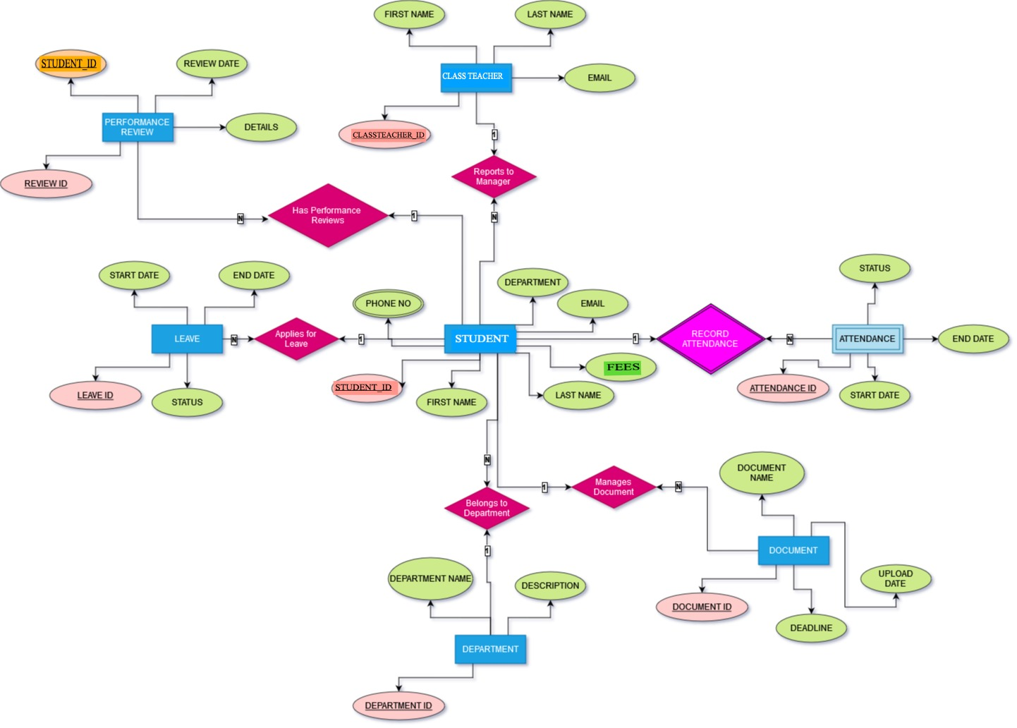

**ER TO RELATIONAL MAPPING**

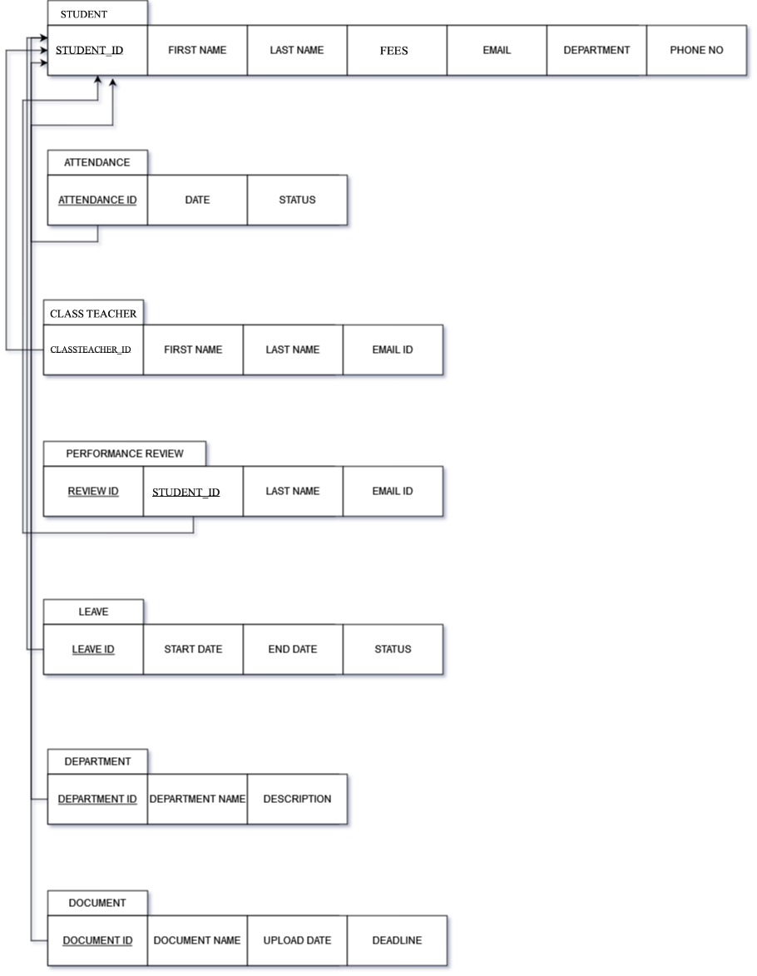

**DDL STATEMENTS**

**CREATING THE TABLES**

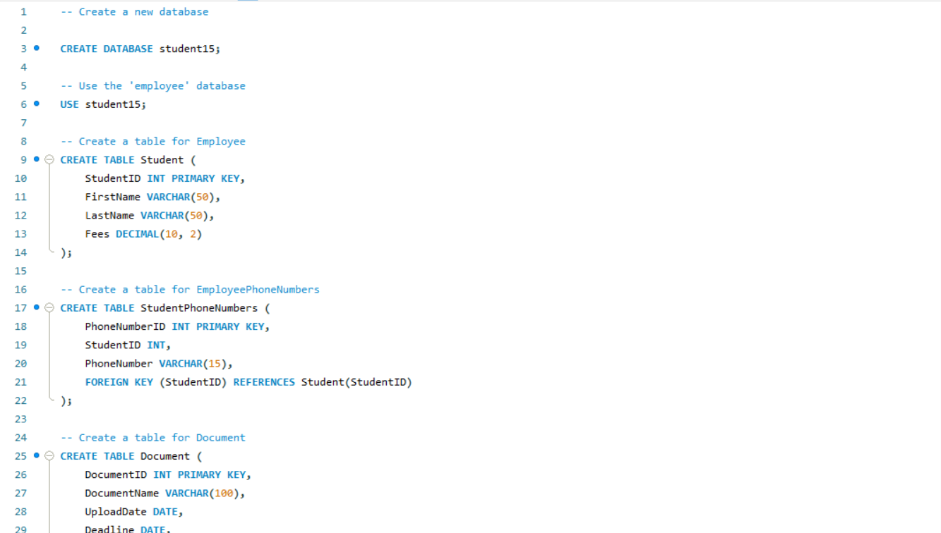

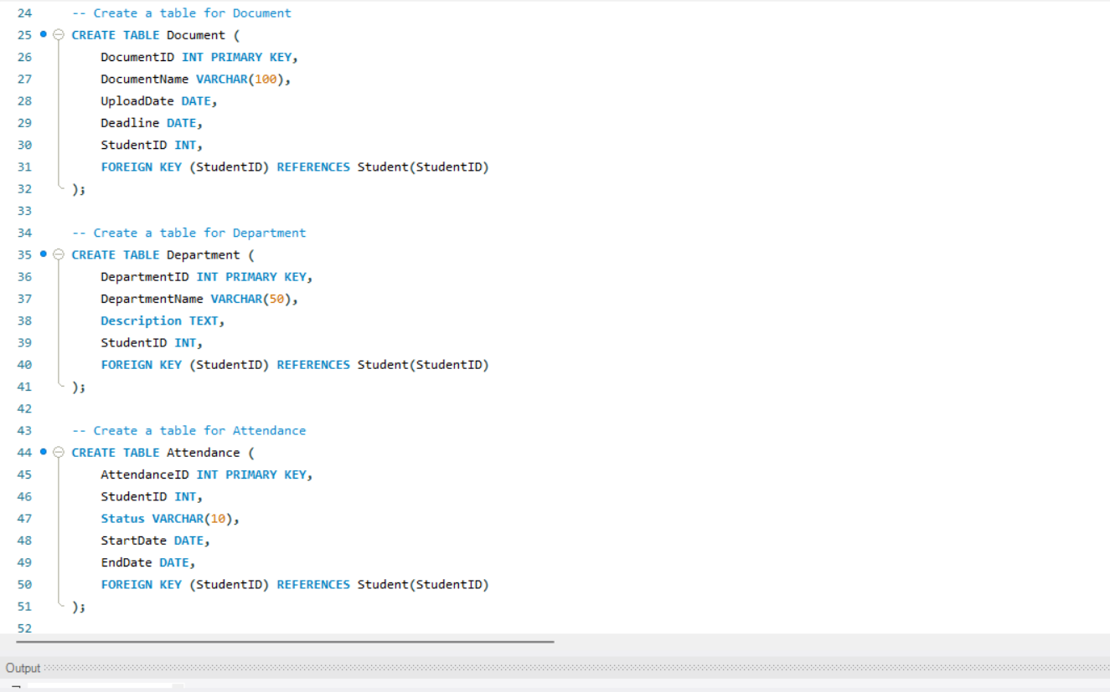

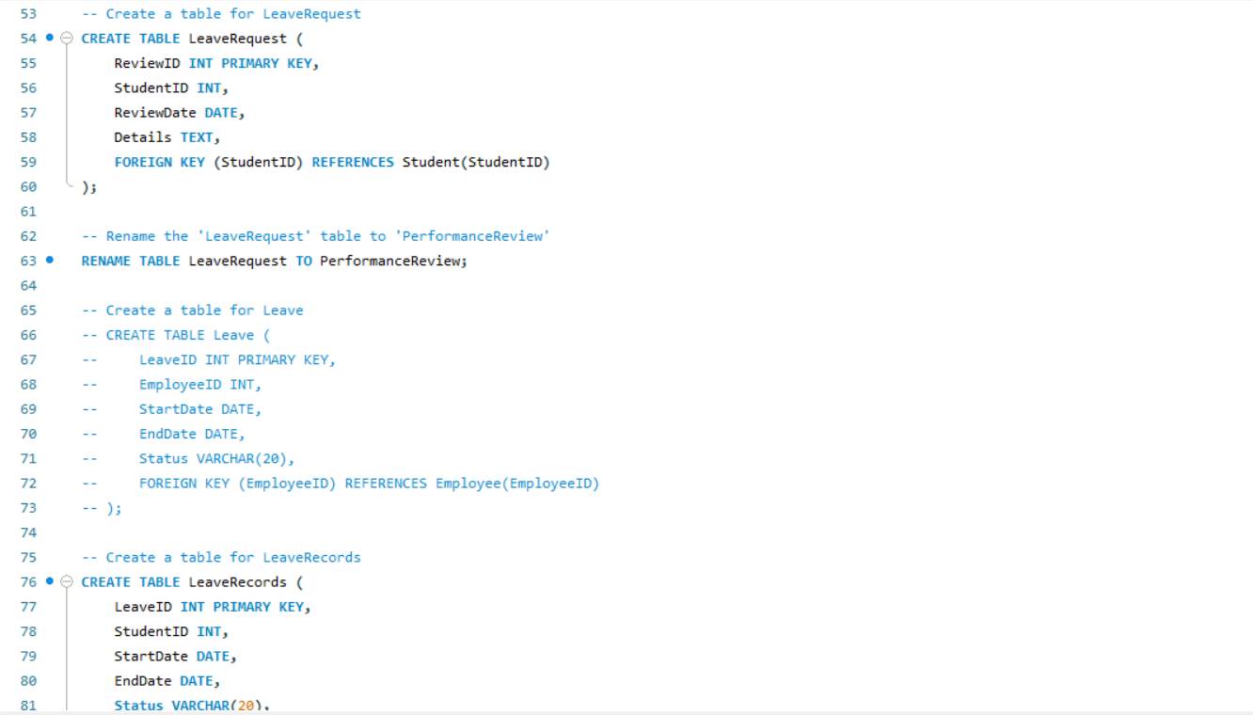

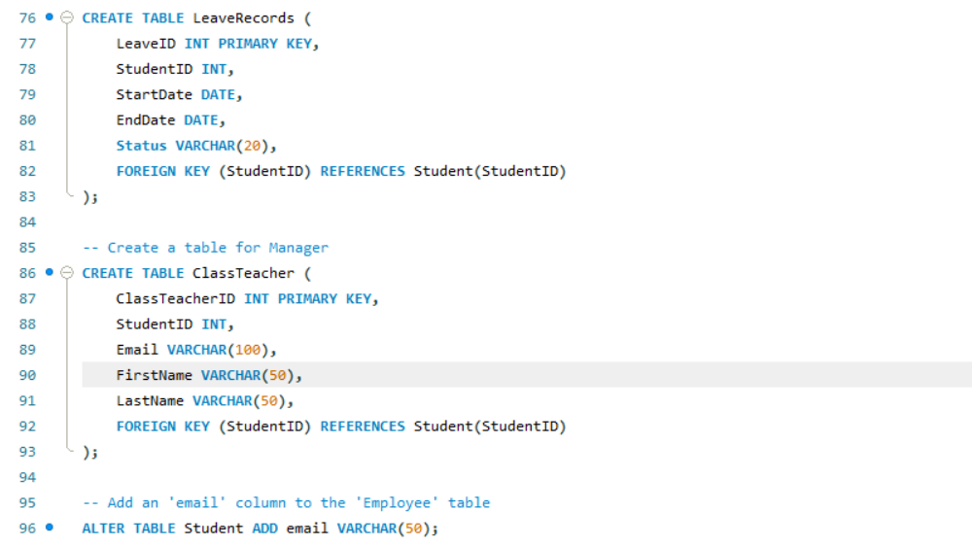

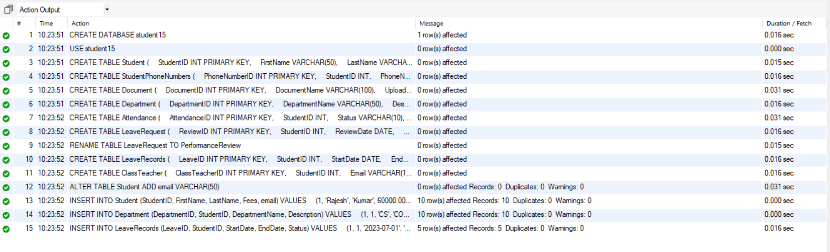

**DML STATEMENTS**

**INSERTING THE VALUES INTO TABLES**

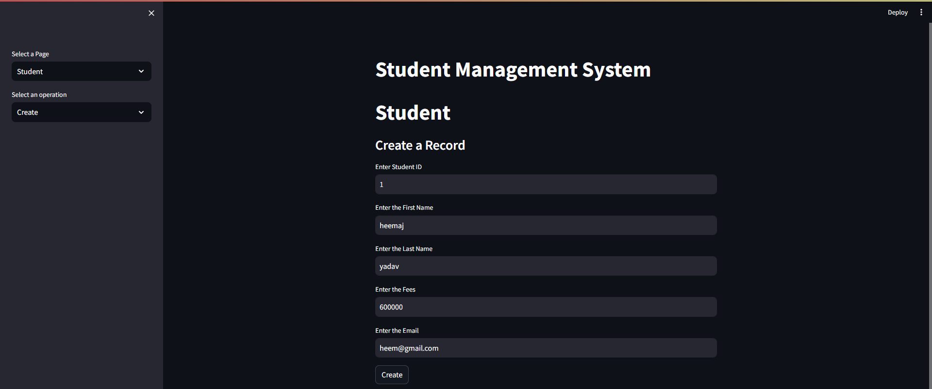

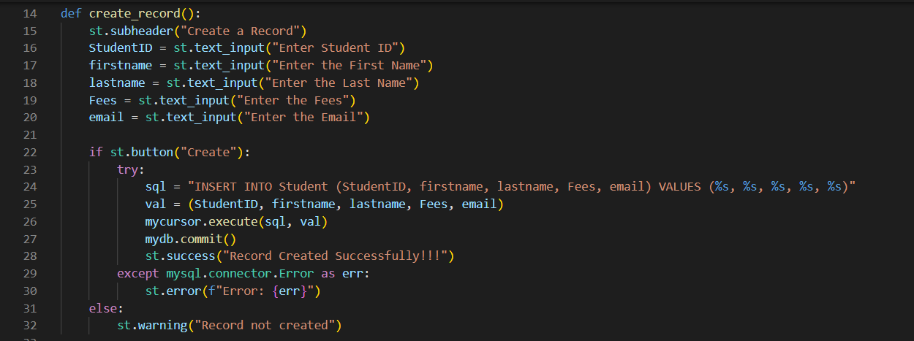

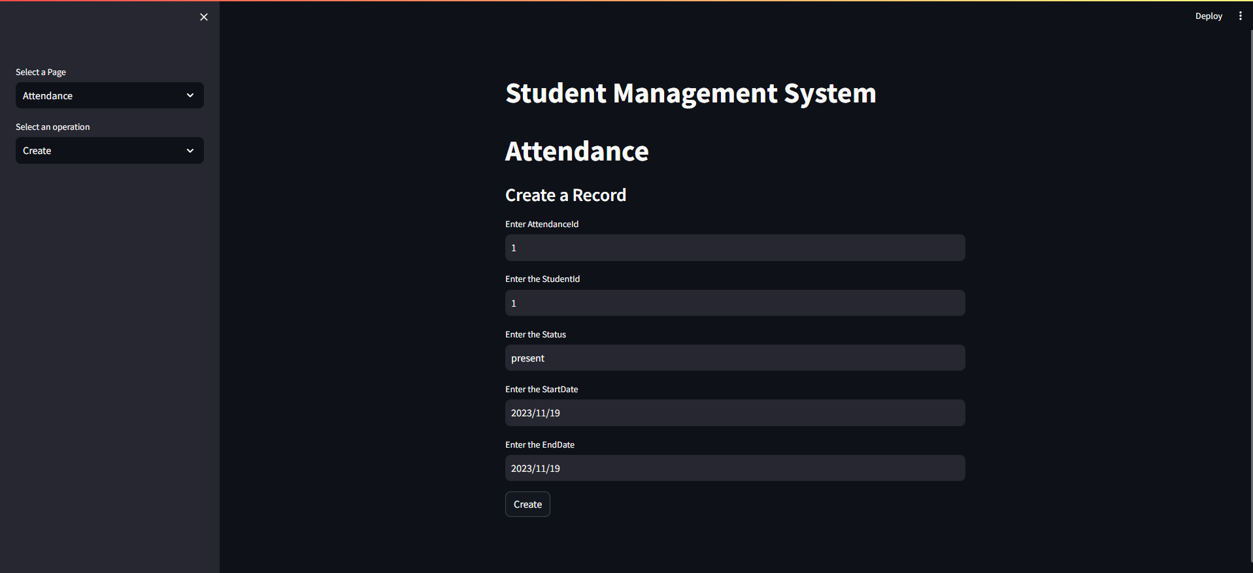

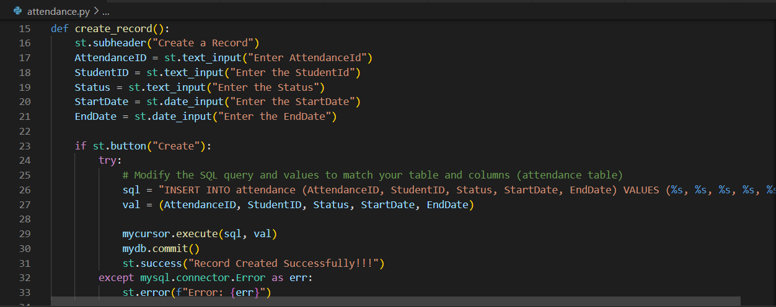

**QUERIES**

**SIMPLE QUERY WITH GROUP BY, AGRREGATE**

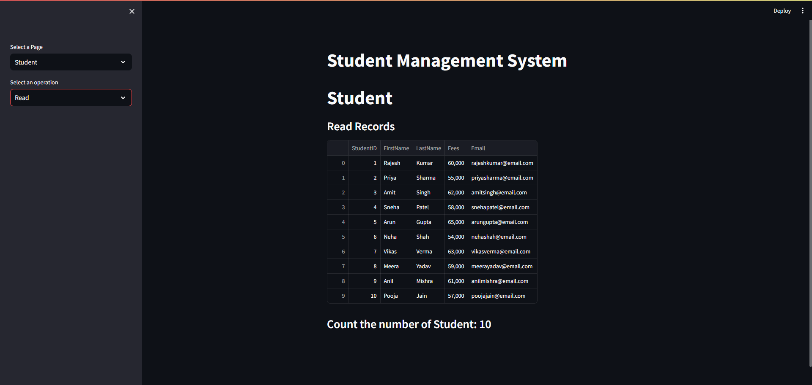

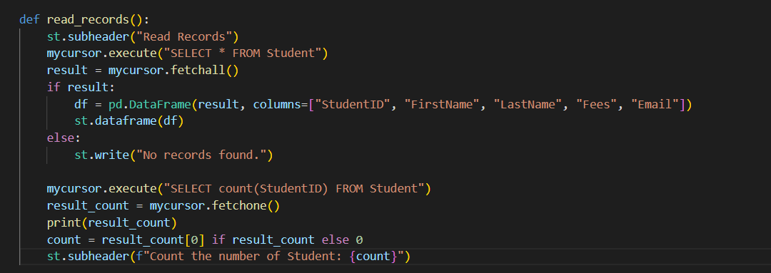

**UPDATE OPERATION**

**Update the table information by entering the primary key attributes**

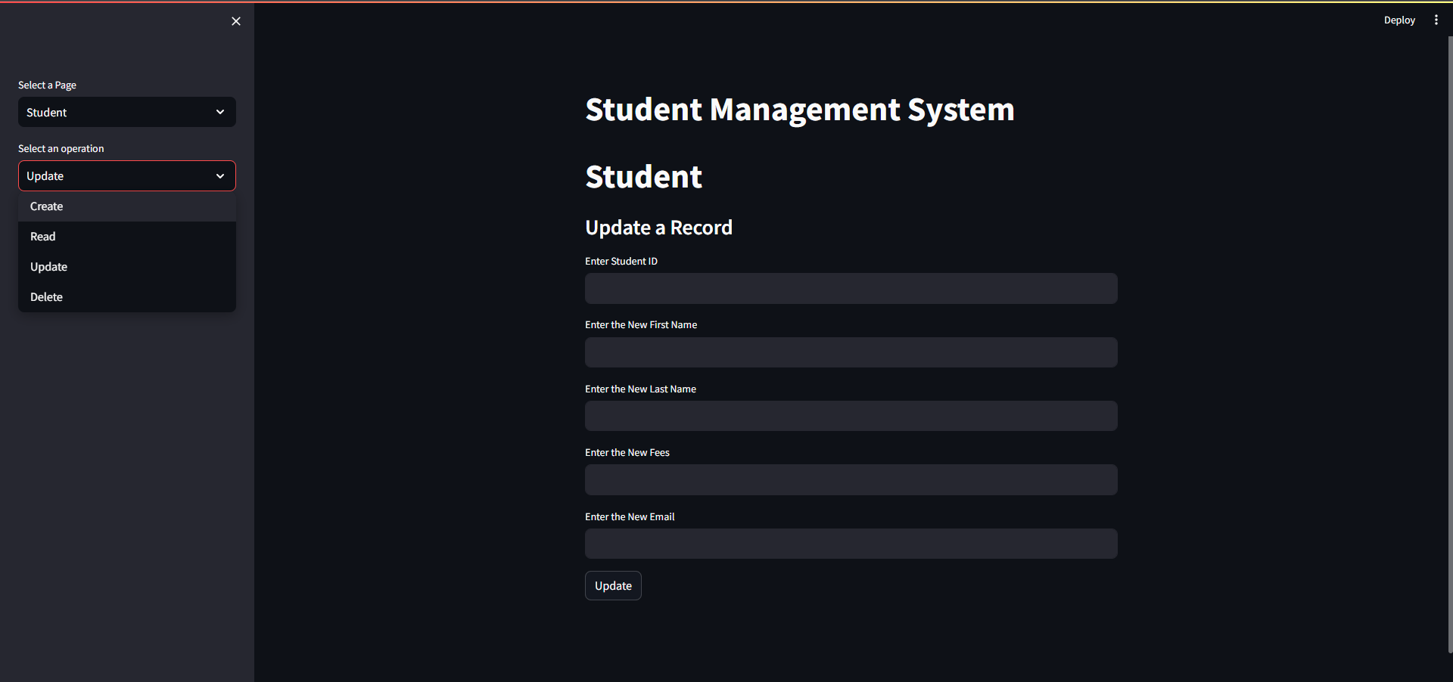

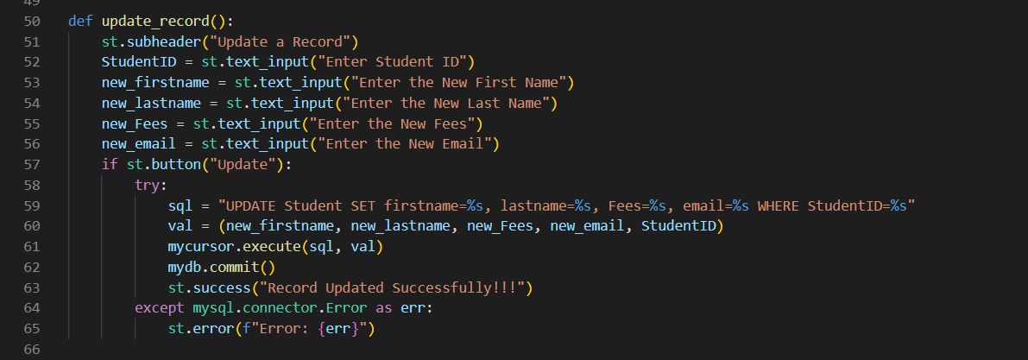

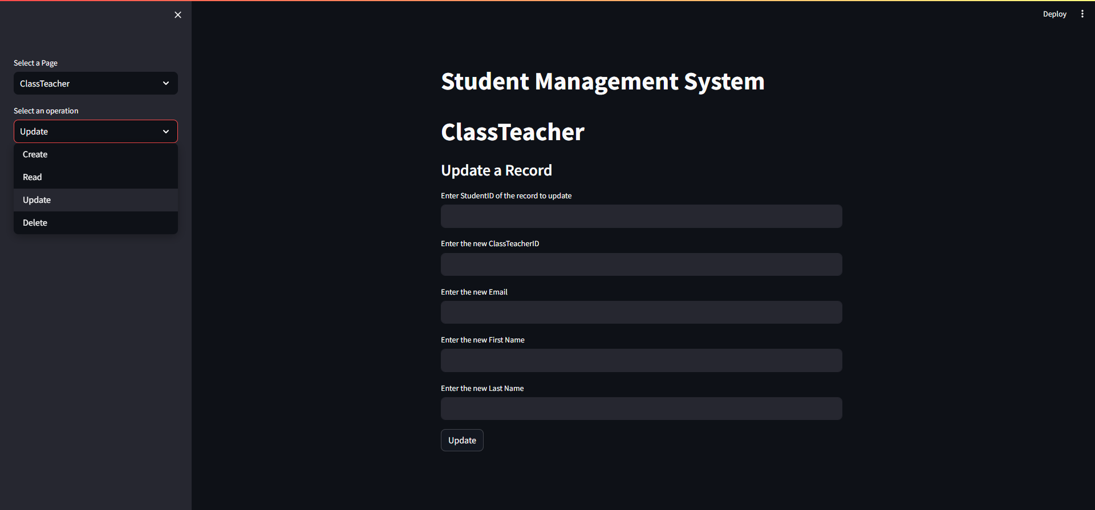

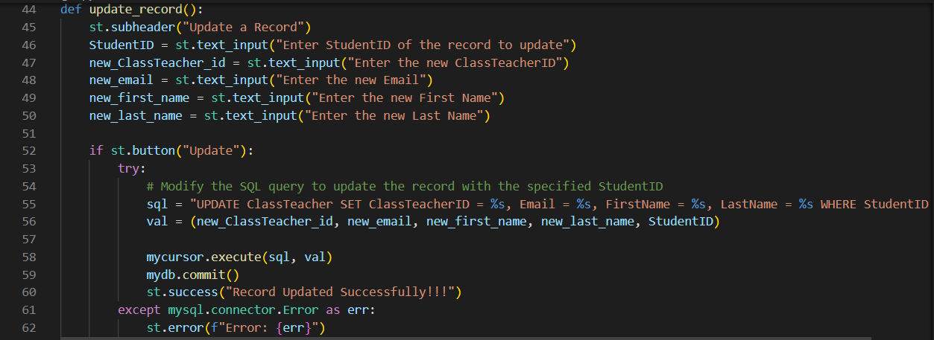

**DELETE OPERATION**

**Deletes the specified records taking StudentID as input**

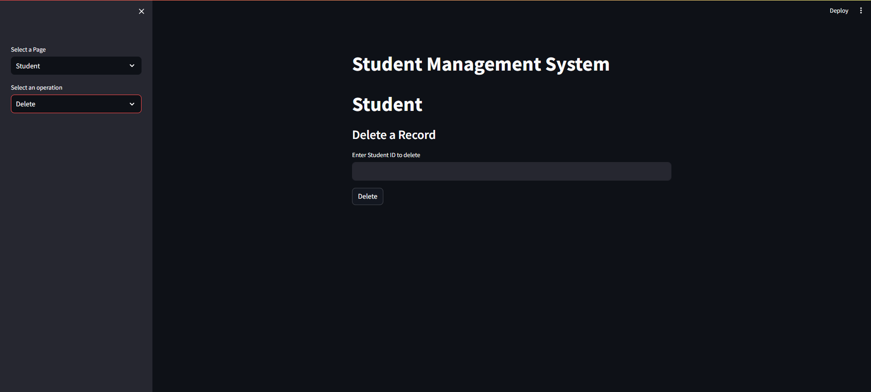

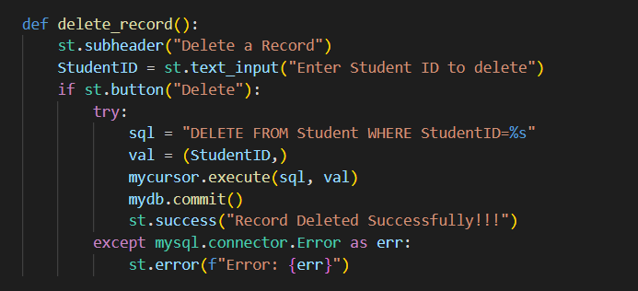

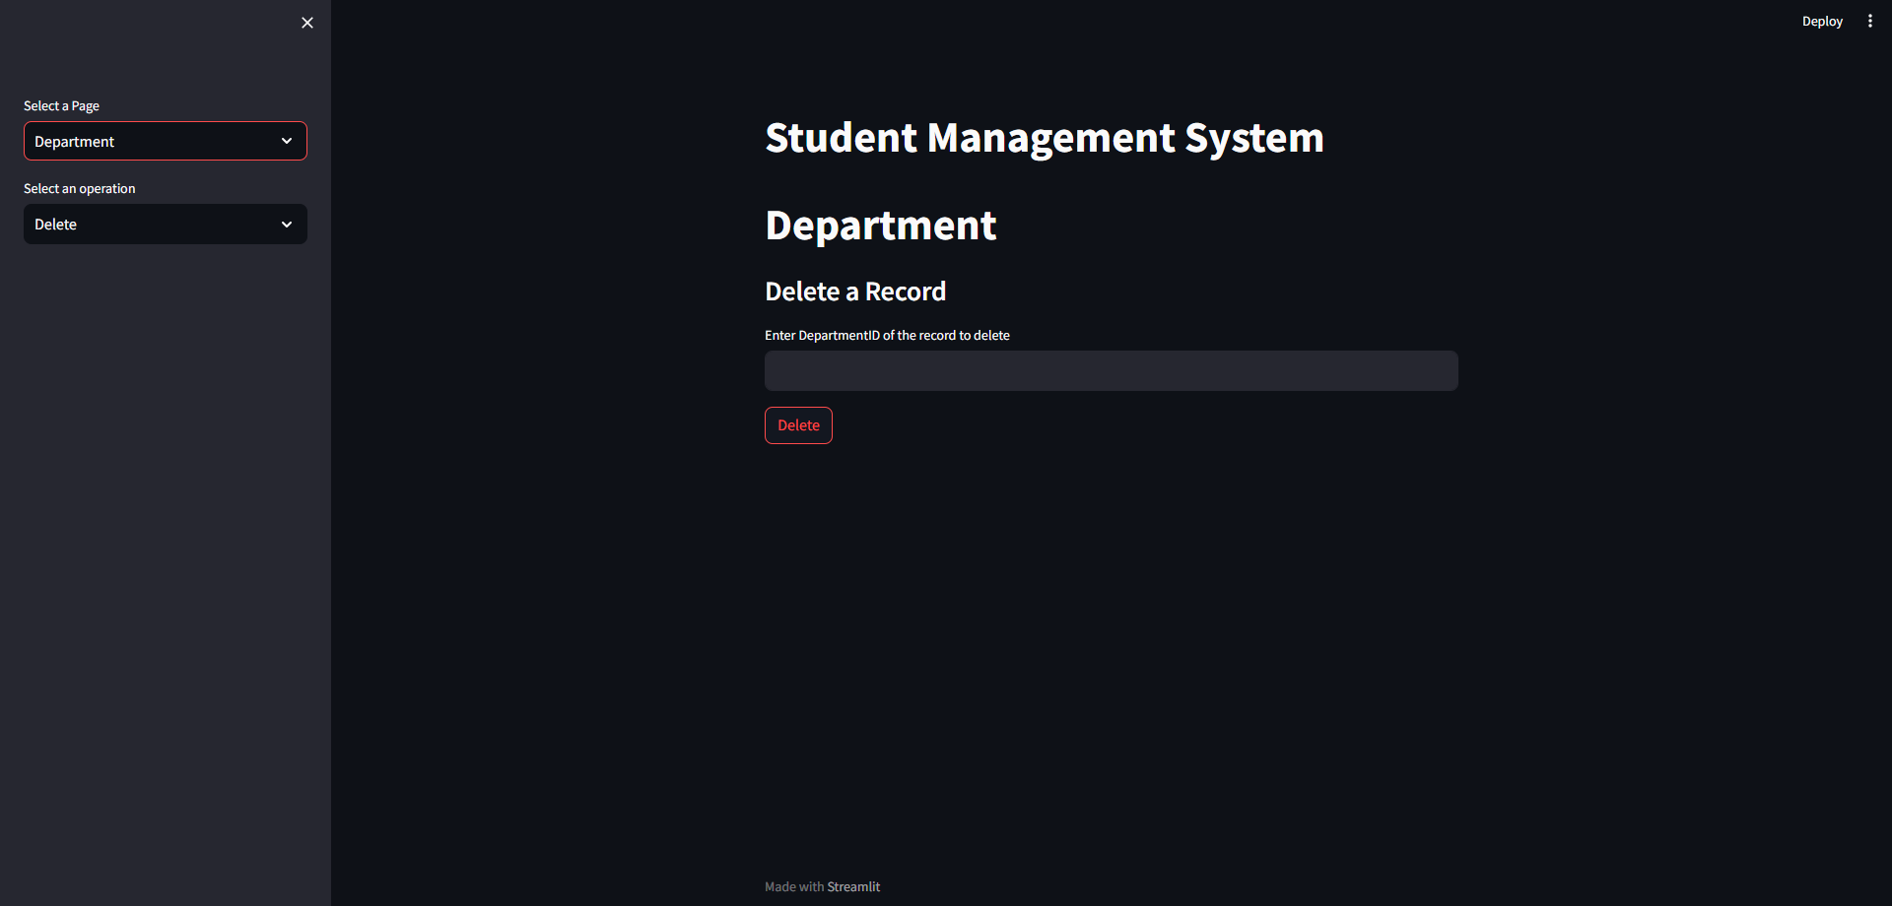

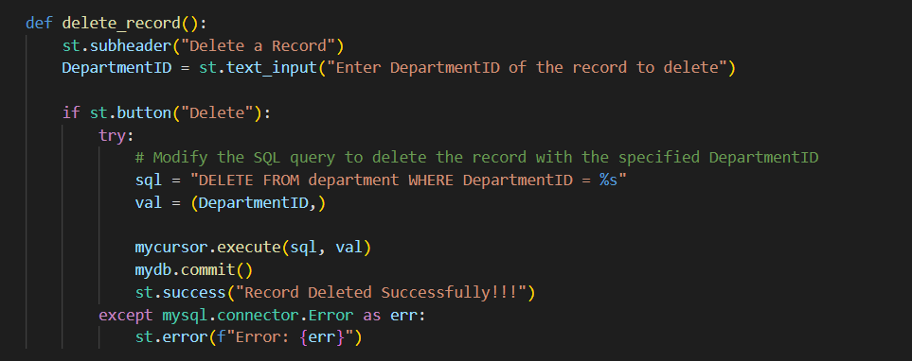

**JOIN QUERY**

**To join two tables with same StudentID using inner join**

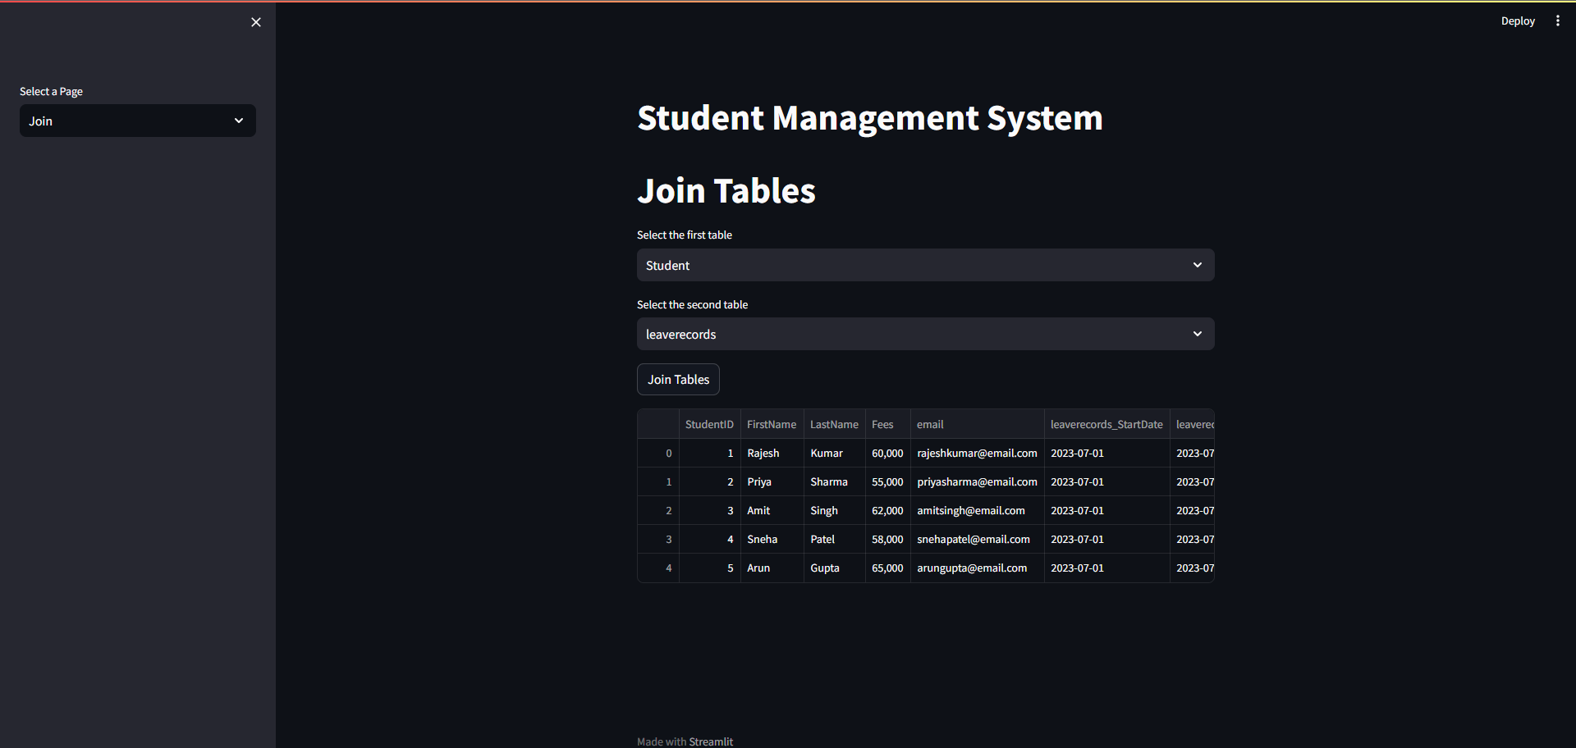

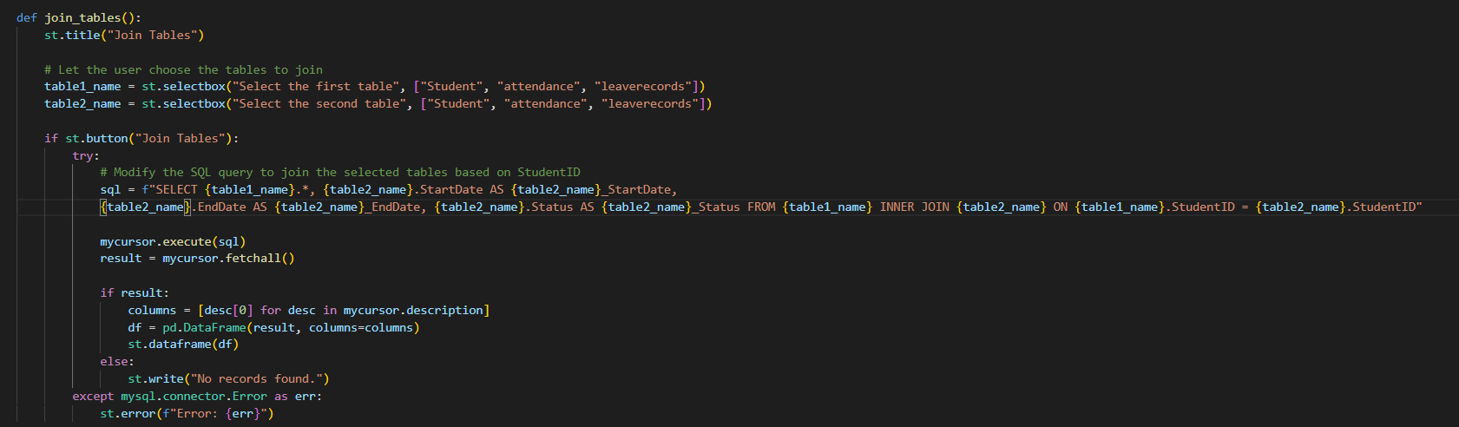

**COUNT FUNCTION**

**This function counts the total number of records**

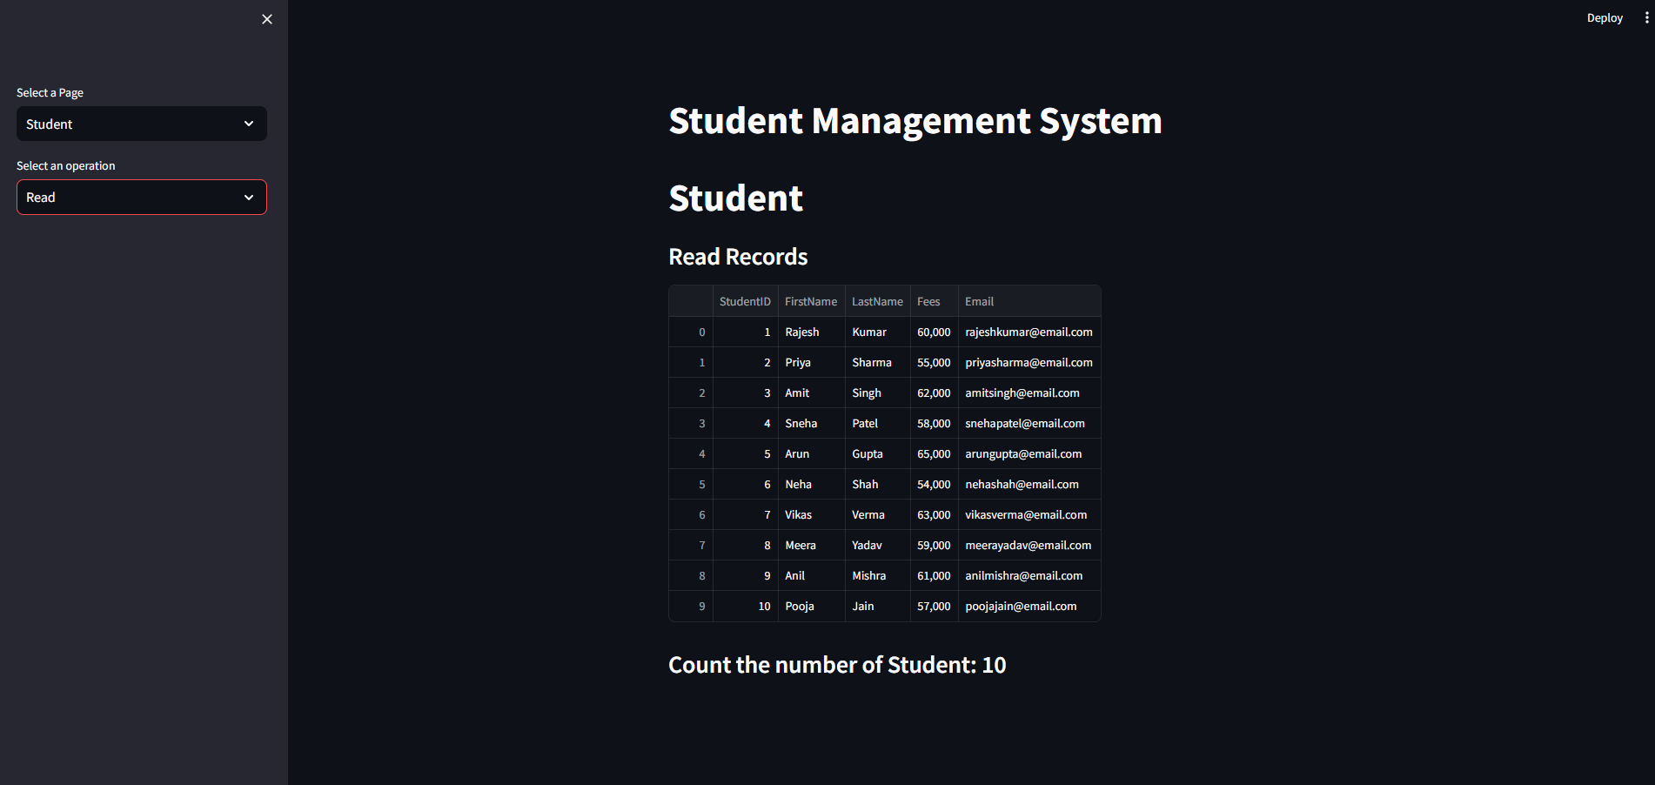

**TRIGGERS**

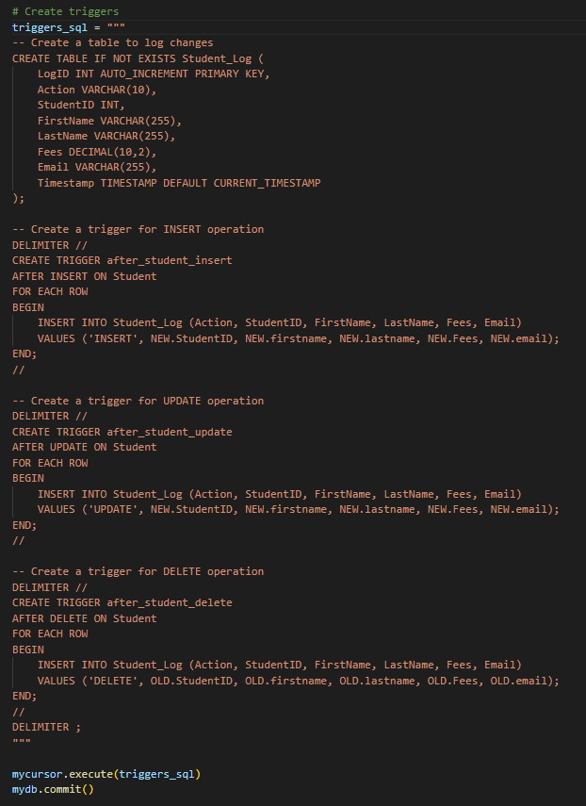

**FRONT END DEVELOPEMNT**

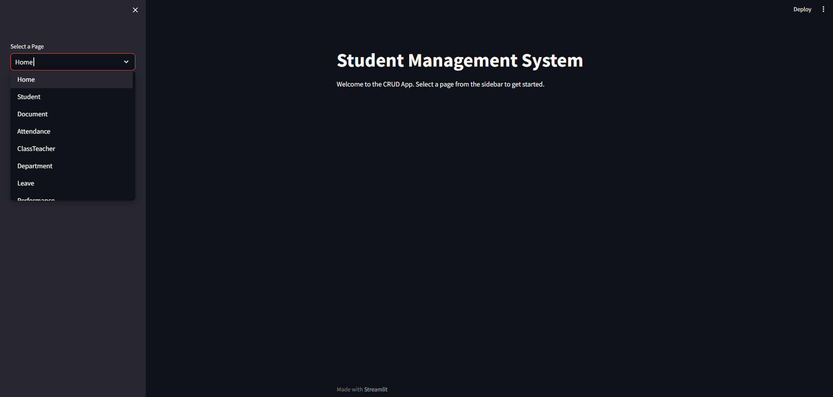

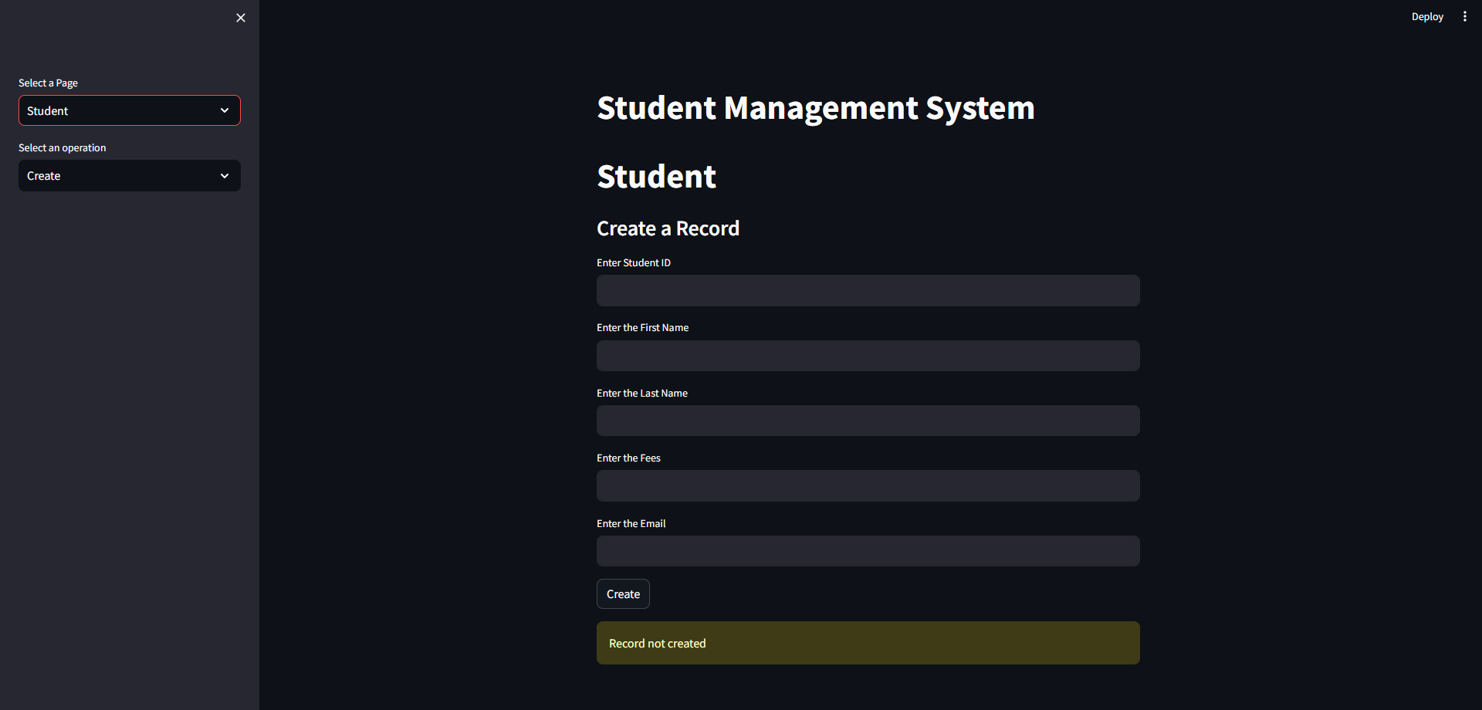

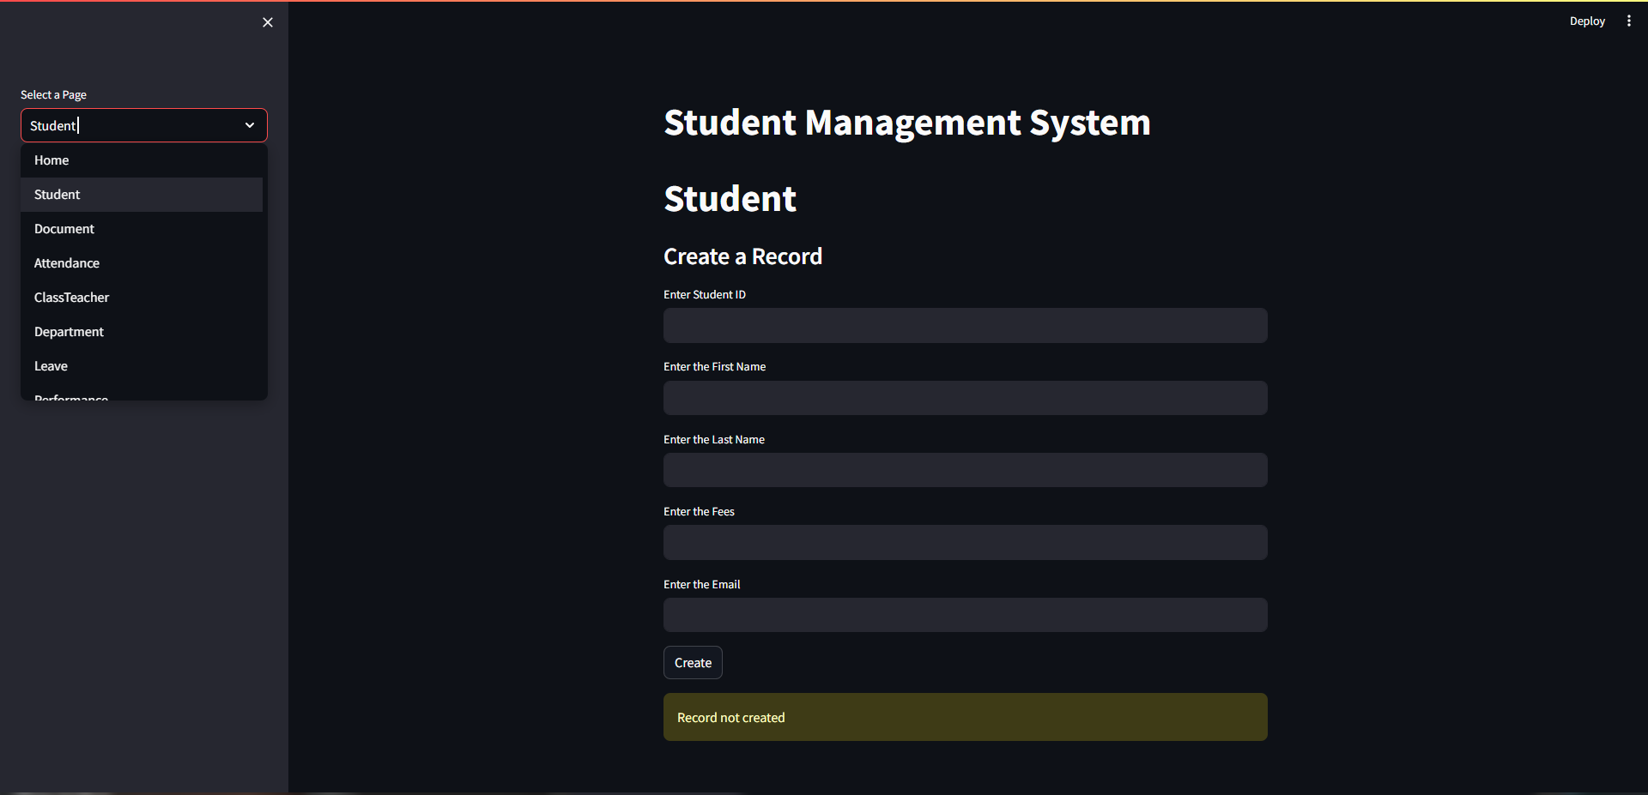

**REFERENCES**

* 1. [**www.youtube.com**](http://www.youtube.com)
  2. [**www.github.com**](http://www.github.com)